A Driving Decision Strategy (DDS) Based on Machine learning for an autonomous vehicle

Dataset discription:  
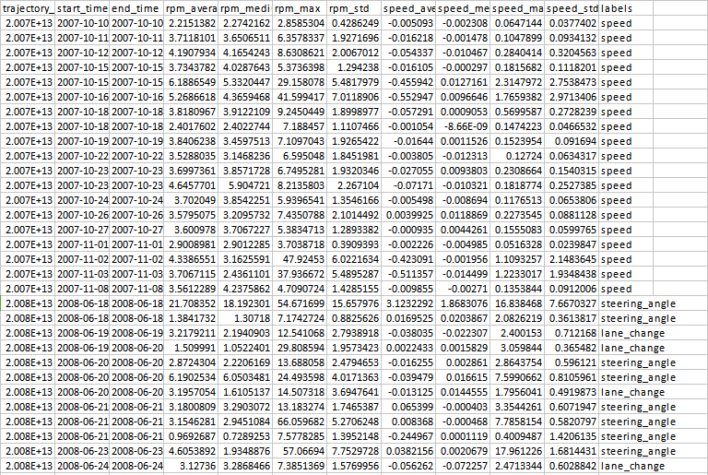

The datase consists of 978 records and twelve columns. Out of twelve columns 11 columns are DDS dataset features and one column is class label. Class label consists either speed or steering_angle or lane_change.

Importing required packages

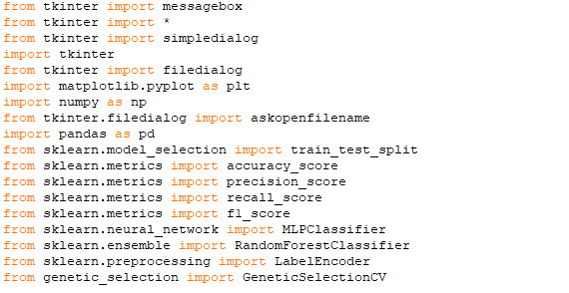

Upload dataset



Generate model

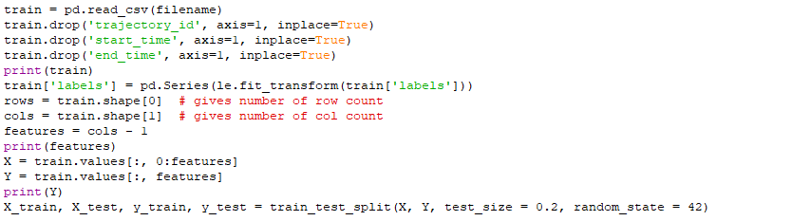

Applying machine learning algorithms

Random forest

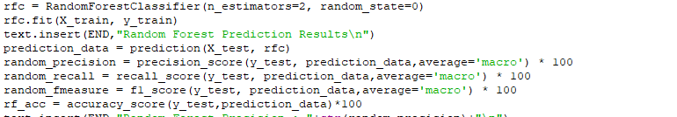

RF accuracy:67.3469387755102

MLP:

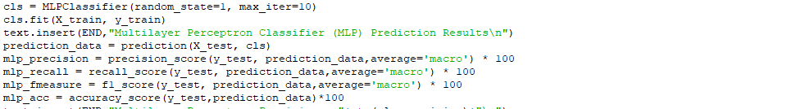

MLP accuracy:48.97959183673469

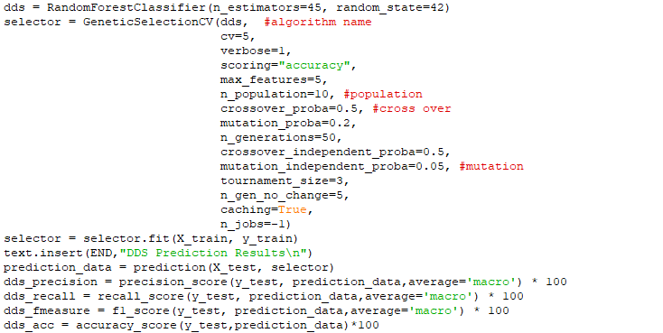

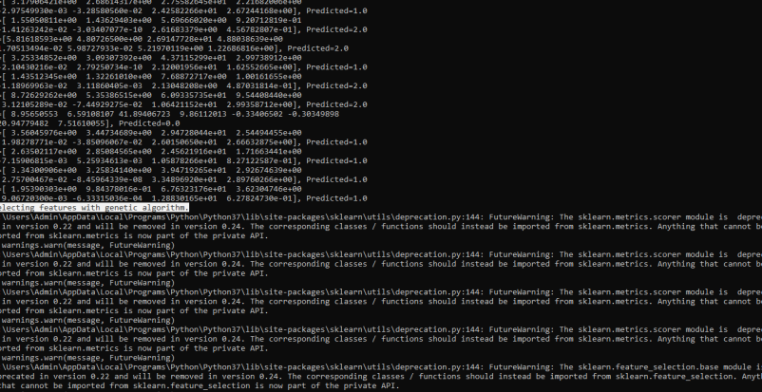

Upload DDS dataset for prediction

